Students Name: ____________________

Teacher: ______________________

NARROGIN SENIOR HIGH SCHOOL
YEAR 11 – HUMAN BIOLOGY

Semester 2 Examination 2004

Time Allowed: Reading time: 10 minutes
Working time: 2.5 hours

Material provided for this paper:

Question Paper
Answer Booklet (containing Part A answer sheet and lined paper for part C)

Instructions to candidates:

Part A: Questions 1 – 40
Choose the best answer and mark the appropriate “letter”
with “X” on the answer sheet provided. 80 marks

Part B: Question 41 – 45
Fill in the answers in spaces provided on question paper.
100 marks

Part C: Extended answer 46 and 47
Attempt TWO questions. Write your answer on the paper
provided. 20 marks

Total 200 marks

Equipment required: pens, grey lead pencil, ruler and scientific calculator (graphics
calculators are not permitted).

Section | Possible Mark | Actual Mark
Part A: Questions 1 - 40 | 80
Part B: Questions 41 – 45 | 100
Part C: Questions 47 & 48 | 20
Total | 200

Part A

Answer all multiple-choice questions on the answer sheet provided. Select the best alternative.

The diagram shows a parent cell with four chromosomes at an early stage of
Meiosis.
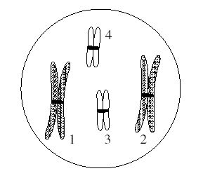
- Which of the following cells is most likely to be produced at the end of the first meiotic division?
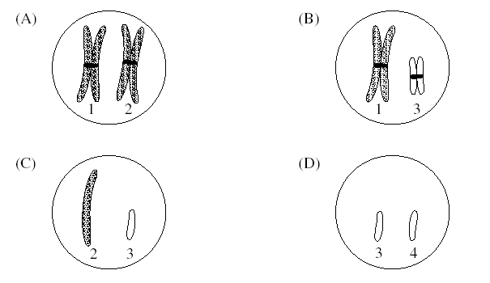
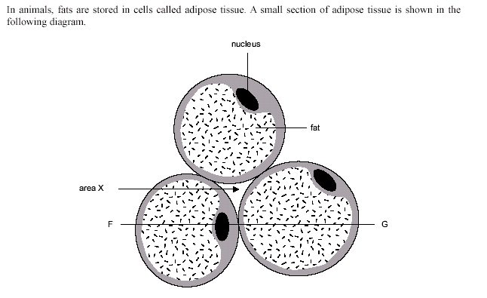

- Adipose cells are usually yellow in colour because of the fat that accumulates as an oil drop within each cell. The cytoplasm is a thin shell around the drop of fat but expands a little around the flattened nucleus.

Area X would comprise
  - fats.
  - blood.
  - water.
  - tissue fluid.

A student set up an experiment with a semi permeable membrane. The membrane was not permeable to sucrose. At the beginning of the experiment the same amount of water was added to both sides of the membrane. The student then added sucrose to the left side of the membrane as shown in the following diagram.

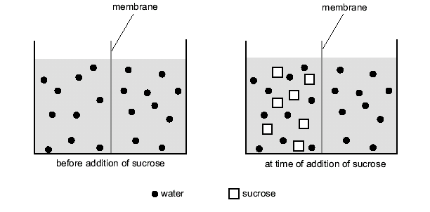
- The student then added sucrose to the left side of the membrane as shown in the following diagram. You would expect
A the level of water to rise on the left of the membrane.
B the level of water to rise on the right of the membrane.
C the level of water to remain unchanged on both sides of the membrane.
D the concentration of sucrose to increase on the right side of the membrane.

- In mammals, organs are grouped into systems, for example the endocrine system, on the basis that they are
- close together.
- similar in structure.
- related through function.
- formed at the same time of development.

5 Enzymes are

- Carbohydrates that have the ability to catalyse reactions.
- Proteins that speed up chemical reactions.
- Carbohydrates that are denatured at very high temperatures.
- Proteins that are used up in chemical reactions.

6 Anaerobic respiration can involve

- The production of lactic acid in muscle cells.
- The production of ADP in skin cells.
- The use of oxygen by mitochondria.
- The production of oxygen by the cytoplasm.

7 Large molecules move out of cell by

- Exocytosis.
- Phagocytosis
- Plasmolysis
- Pinocytosis

The following diagram shows what red blood cells look like in blood vessels.

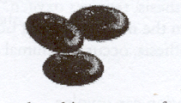

Some of these blood cells were placed in a range of solutions with different solute concentrations. The appearance of the cells after one minute in the solution is shown in the following diagram.

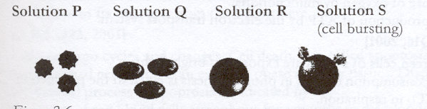

  - From the results shown above it would be reasonable to conclude that

- Solution P is hypotonic to the red blood cell.
- Solution Q has a higher water concentration than the red blood cell.
- Solution R has a lower solute concentration than the red blood cell
- Solution S has approximately the same solute concentration as the red blood cell.

9. Which of the following organelles would you expect to be more numerous in a muscle cell than in a bone cell?

- Ribosome
- Mitochondria
- Centriole
- Lysosome

10 When the nucleus is removed from a cell and replaced within two days the cell survives. If it is not replaced the cell dies.
Which of the following statements best explains these results?

- The nucleus is the major site of energy production in the cell.
- The nucleus contains DNA which controls cell division
- The nucleus supplies information, which is necessary for maintaining chemical processes.
- The nucleus is the major site of protein synthesis in the cell.

11 ATP is essential to every living cell because it

- Reacts with energy from glucose to form ADP.
- Speeds up digestion of carbohydrates.
- Stores energy in a form that is instantly available
- Stores energy released during the breakdown of ADP.

12 The major difference between sperm and ova is that

- Sperm have only one sex chromosome
- Ova are unable to propel themselves from the ovary to the uterus.
- Ova have 23 chromosomes, sperm have 22.
- Only ova have an X chromosome, sperm have only Y-chromosomes.

13 Chemicals used in the oral contraceptive (the pill)

- Are oestrogen, progesterone and FSH
- Are used to destroy any ova that are maturing.
- Destroy the sperm as they enter the female reproductive tract.
- Create similar hormone concentrations that exist during pregnancy.

14 Within two weeks of conception, the inner cell mass of the blastocyst has developed three layers each with a definite destination in the developing embryo. The ectoderm will form

- Nervous system, skin, hair and nails.
- Muscle, bone, cartilage and blood vessels
- Heart and lungs
- Large intestine, small intestine and stomach

15 Which of the following best describes the first stage of the dying process?

- Body temperature falls and disintegration occurs.
- The heart stops beating and the brain loses consciousness
- The hairs on the skin stand erect
- The pupils dilate and the person urinates.

16 Identical twins are the result of:

- two sperm fertilising one ovum.
- two ova fertilised by two sperm.
- one sperm dividing and fertilising two ova.
- one fertilised ovum dividing to form two embryos.

17 FSH is a hormone, which has the function of:

- promoting lactation after childbirth.
- controlling reabsorption of water from the kidney tubules.
- stimulating follicle cells and ensuring development of a maturing ovum.
- regulating metabolic rate.

Consider the following graph:
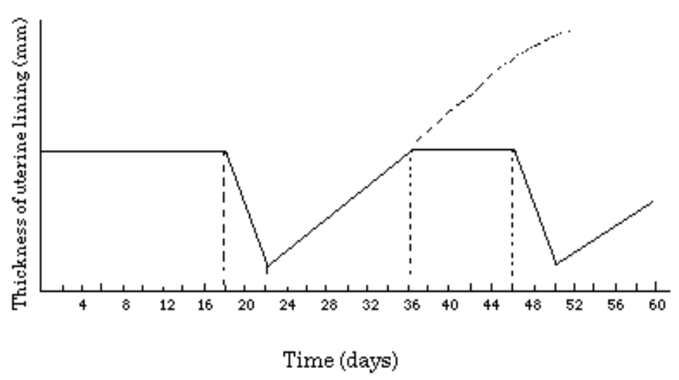

18 If the thickness of the uterine lining increases as shown by the dotted line it indicates that:

- sperms have entered the vagina.
- an egg has been released from the ovary.
- a hormone secreted from the ovary.
- a fertilized egg has implanted in the uterine wall.

19 The promotion of skeletal and muscular growth, and the development of secondary sexual characteristics in boys at puberty is due to the hormone:

- oestrogen.
- spermatogen.
- testosterone.
- pitressin.

20 Which of the following best describes the order of the Kubler-Ross psychological stages of the dying process?

- Acceptance, Denial, Depression.
- Bargaining, Anger, Denial.
- Denial, Bargaining, Acceptance.
- Depression, Bargaining, Anger.

21 The part of the testes, which act as endocrine glands are the:

- seminiferous tubules.
- interstitial cells.
- tunica albuginea.
- germinal epithelial cells.

Consider the following graph of the human menstrual cycle. On it are plotted the amounts of three hormones, oestrogen, progesterone and luteinising hormone (LH) as well as uterine wall thickness:
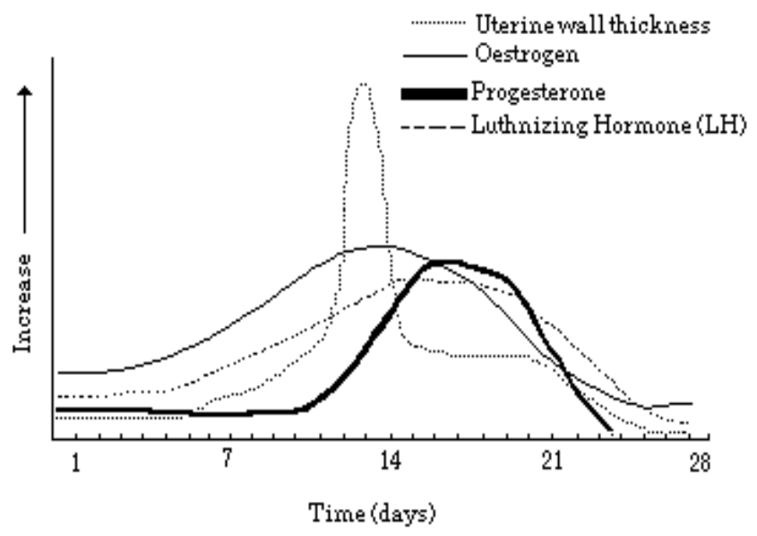

22 Progesterone secretion decreases sharply near the end of the cycle because:

- the corpus luteum degenerates.
- the corpus luteum appears.
- ovulation occurs.
- pregnancy results.

23 A short time after the baby is born, the "after birth" is expelled. This is the:

- membranous bag that contained the baby.
- wastes produced by the developing foetus.
- watery fluid also called colostrum.
- placenta and associated foetal membranes.

24 The most vulnerable time for adverse effects on the development of the foetus is during:

- conception.
- the first three months.
- the last trimester.
- birth.

25 In the stage of human development in the week immediately before birth, the developing child is called:

- a blastula.
- an embryo.
- a foetus.
- a zygote.

26 In a foetus, the foramen ovale:

- equalises the quantity of blood in both halves of the heart.
- maintains equal blood pressure in both halves of the heart.
- allows blood, both oxygenated and deoxygenated to mix.
- allows blood to flow directly from the right side to the left side without going to the lungs.

27 Which of the following cannot pass across the placenta?

- Oxygen.
- Waste products.
- Blood.
- Nutrients.

28 The hormone responsible for milk letdown, and uterine contractions during labour is:

- progesterone.
- oestrogen.
- oxytocin.
- leutinising hormone.

29 An early stage in the development of the human embryo in which the cells have formed a hollow sphere is the:

- zygote.
- foetus.
- blastula.
- chorion.

30 The most rapid spurt of growth after birth is:

- 0-2 years.
- 5-10 years.
- 12-15 years.
- 16-20 years

The following table shows:
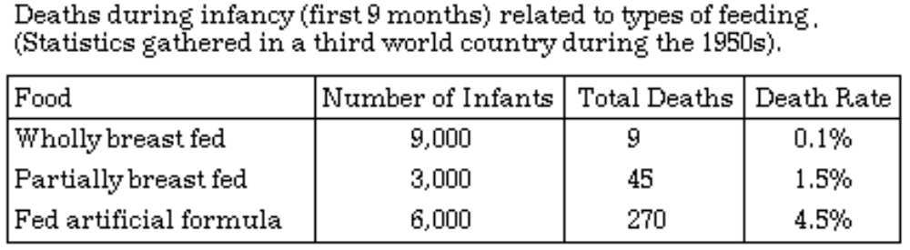

31 From the table above the death rate amongst infants fed an artificial formula is:

- 6.0 times greater than that for partially breast-fed infants.
- 30.0 times greater than that for wholly breast-fed infants.
- 4.0 times greater than that for partially breast-fed infants.
- 45.0 times greater than that for wholly breast-fed infants

32 The process of ageing is NOT necessarily made evident by:

- increasing fragility of bone.
- calcification of cartilage.
- atrophy of intervertebral discs.
- loss of potential or usefulness

33 A muscle that causes an increase in the joint angle is known as:

- an extensor.
- an abductor.
- an adductor.
- a flexor.

34 The gluteal muscles are those we use in:

- bending an arm.
- nodding the head.
- walking and climbing.
- a knee jerk reflex.

35 In passing from the lungs to the kidneys, the blood would have to pass through the:

- pulmonary vein, bicuspid valve and aorta.
- pulmonary artery, bicuspid valve and aorta.
- pulmonary vein, tricuspid valve and aorta.
- bicuspid valve, aorta and renal vein.

36 The major artery carrying deoxygenated blood is the:

- aorta.
- superior vena cava.
- pulmonary artery.
- subclavian artery.

37 Which of the following comparisons between the blood and lymphatic system is INCORRECT?

Blood system Lymphatic System

- The flow is away from the heart. The flow is towards the heart.
- The system leaks fluid into the The system collects up the
tissues. leaked fluid.
- Valves are present in some of the Valves also present.
vessels.
- Contains red blood cells. Contains no red blood cells.

Refer to the following diagram to answer question 38.
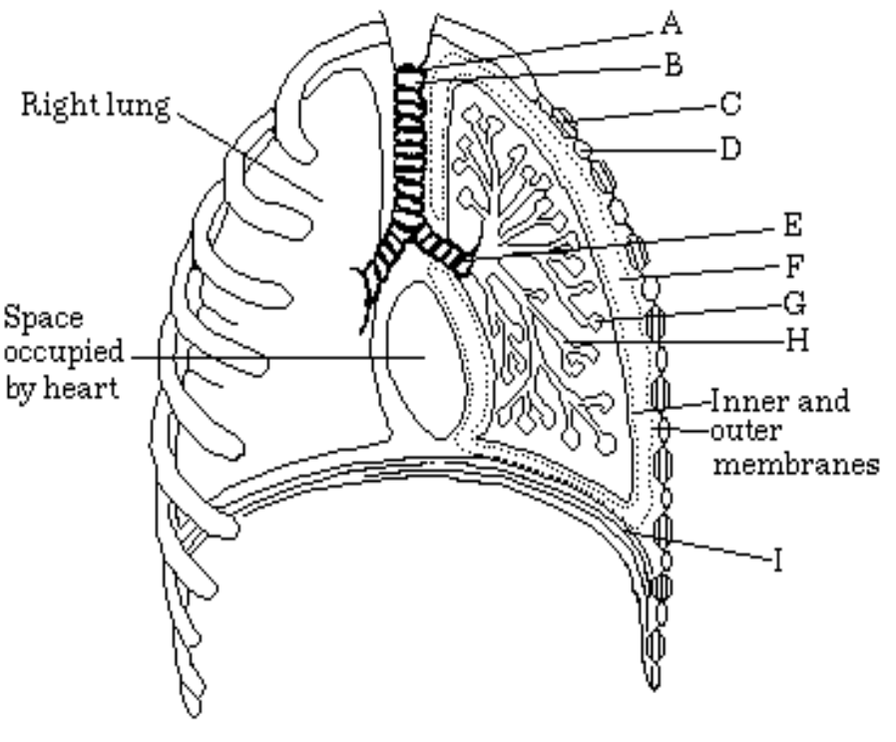
38 Which of the following pairs of structures cause the pressure in the lungs to decrease during inspiration ?

- A and I.
- F and I.
- C and F.
- C and I.

39 For optimum gas exchange, the alveoli in the lungs should have:

- thick walls that have a large surface area.
- muscular walls with the potential to expand significantly.
- thin mucus covered walls.
- thin walls with the maximum possible surface area.

40 The rate of external respiration is increased by:

- a high level of CO2 in blood.
- a high level of O2 in blood.
- a low level of CO2 in blood.
- faster breathing.

Section B: Short Answer 100 Marks

Attempt all questions in this section. Write answers in the spaces provided. Use blue or black pen.

41
i) A small insect-eating mammal is thought by some biologists to be a primitive primate.
Describe THREE structural features you would look for that would be evidence
that this mammal may be a primate.

__________________________________________________________________

__________________________________________________________________

__________________________________________________________________

__________________________________________________________________

__________________________________________________________________

__________________________________________________________________

__________________________________________________________________

__________________________________________________________________

__________________________________________________________________

(6marks)

The diagram below shows the fossilised lower jaws of three primates.

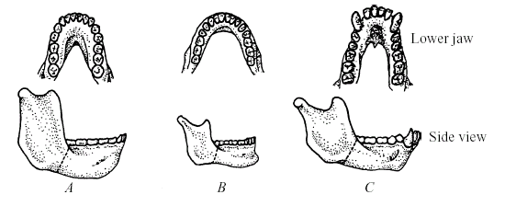

- Which jaw belongs to the most advanced primate?

__________________________________________________________________

(1 mark)
- Give TWO reasons for your answer.

__________________________________________________________________

__________________________________________________________________

__________________________________________________________________

__________________________________________________________________

(2 marks)

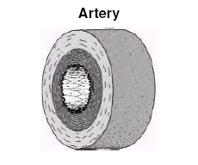
The diagram below is a cross section of an artery.

iv) Label, on the diagram, ONE structural feature of the artery shown.

(1 mark)

v) How does the labelled feature relate to the artery’s function?

__________________________________________________________________

__________________________________________________________________

__________________________________________________________________

__________________________________________________________________

(1 mark)

- Name TWO products extracted from donated blood, and state their uses.

__________________________________________________________________

__________________________________________________________________

__________________________________________________________________

__________________________________________________________________
(2 marks)

vii) Propose ONE reason why scientists have now begun to develop artificial blood.

__________________________________________________________________

__________________________________________________________________

__________________________________________________________________

_______________________________________________________________________________

(1 mark)

The following question relates to the dissected human heart shown below.

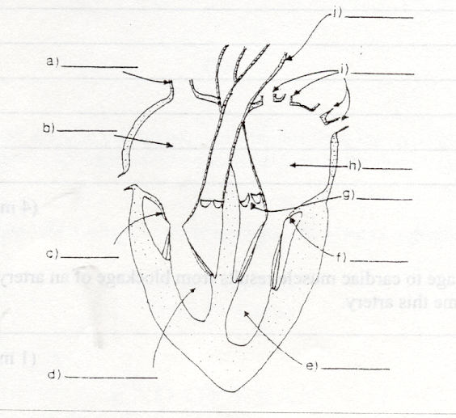

- Name the parts indicated by the letters on the diagram of the heart.

a) ______________________________________________

b) ______________________________________________

c) ______________________________________________

e) ______________________________________________

g) ______________________________________________

i) ______________________________________________

(3 marks)

- Irreversible damage to cardiac muscle results from blockage of an artery not shown in the above diagram. Name this artery.

_________________________________________________________________________

(1 mark)

x) Explain why the left ventricle wall is thicker then the right ventricle wall.

__________________________________________________________________

__________________________________________________________________

__________________________________________________________________

__________________________________________________________________

(2 marks)

TOTAL /20

42
Referring to the following diagram to answer the questions below.

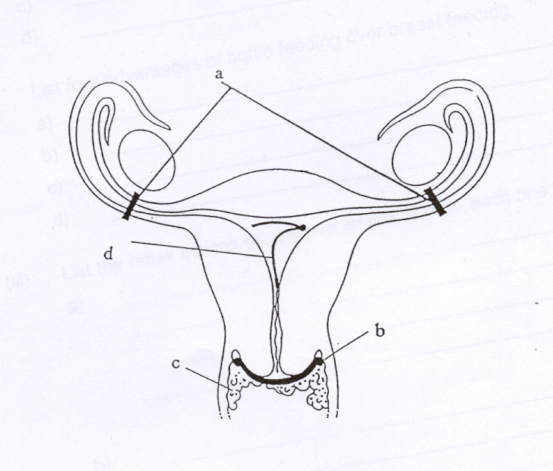

- Name each method of contraception indicated by the letters and explain how they work.

- ____________________________________________________________

____________________________________________________________

____________________________________________________________

____________________________________________________________

____________________________________________________________

- ____________________________________________________________

____________________________________________________________

____________________________________________________________

____________________________________________________________

____________________________________________________________

c ____________________________________________________________

____________________________________________________________

____________________________________________________________

____________________________________________________________

____________________________________________________________

d ____________________________________________________________

____________________________________________________________

____________________________________________________________

____________________________________________________________

____________________________________________________________

(8 marks)

- List two reflex actions of newborn infants and for each one describe the action.

__________________________________________________________________

__________________________________________________________________

__________________________________________________________________

__________________________________________________________________

__________________________________________________________________

__________________________________________________________________

__________________________________________________________________

__________________________________________________________________

(4 marks)

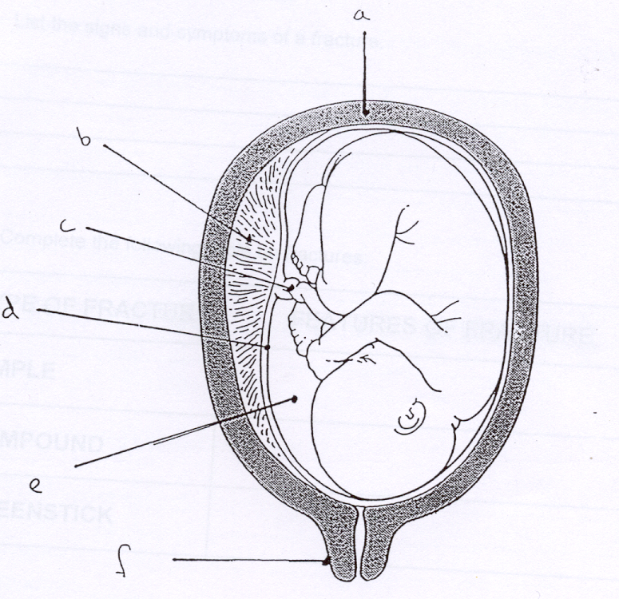
- Provide the names of the structures labelled a-f above.

a) ______________________________________________

b) ______________________________________________

c) ______________________________________________

e) ______________________________________________

g) ______________________________________________

f) _______________________________________________________

(3 marks)

- Explain the function of the fluid in region e

__________________________________________________________________

__________________________________________________________________

__________________________________________________________________
(1 mark)

v) The foetal circulatory system contains the structures ductus arteriosus and foramen ovale which are not present in the mother’s circulatory system. Explain where these structures are located and the function of each.

Ductus arterious

__________________________________________________________________

__________________________________________________________________

__________________________________________________________________

__________________________________________________________________

__________________________________________________________________

__________________________________________________________________

Foramen ovale

__________________________________________________________________

__________________________________________________________________

__________________________________________________________________

__________________________________________________________________

__________________________________________________________________

__________________________________________________________________
(4 marks)

TOTAL /20

43.

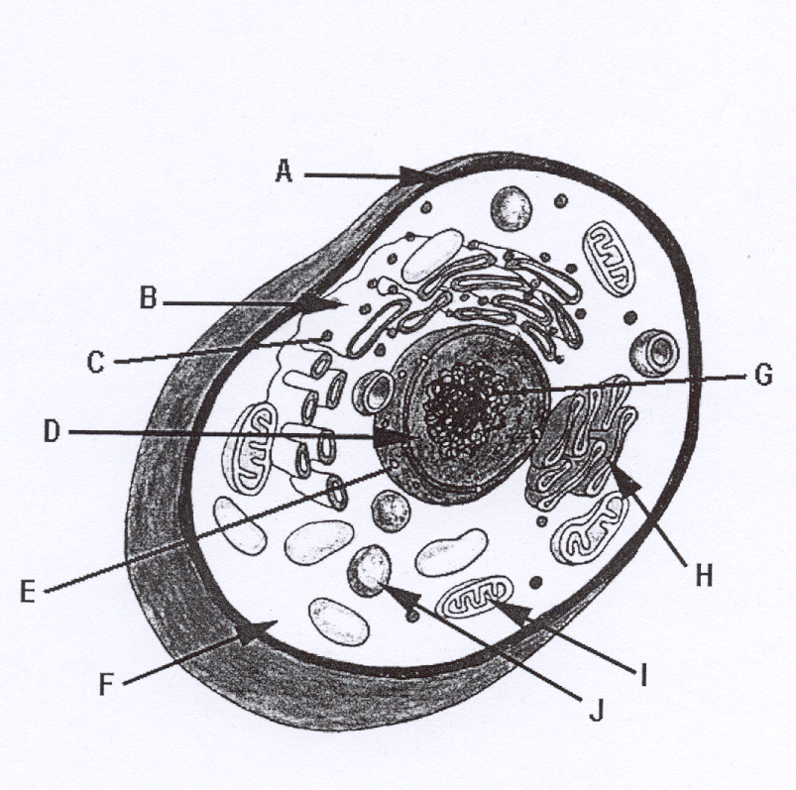

i) Label the following structures.

A ______________________________________________

B ______________________________________________

C ______________________________________________

D ______________________________________________

F ______________________________________________

I ______________________________________________

(3 marks)

- Explain the function of the structures.

A ______________________________________________________

______________________________________________________

______________________________________________________

______________________________________________________

C ______________________________________________________

______________________________________________________

______________________________________________________

______________________________________________________

I ______________________________________________________

______________________________________________________

______________________________________________________

______________________________________________________

(3 marks)
- Identify each of the following tissue types and explain there function
a.
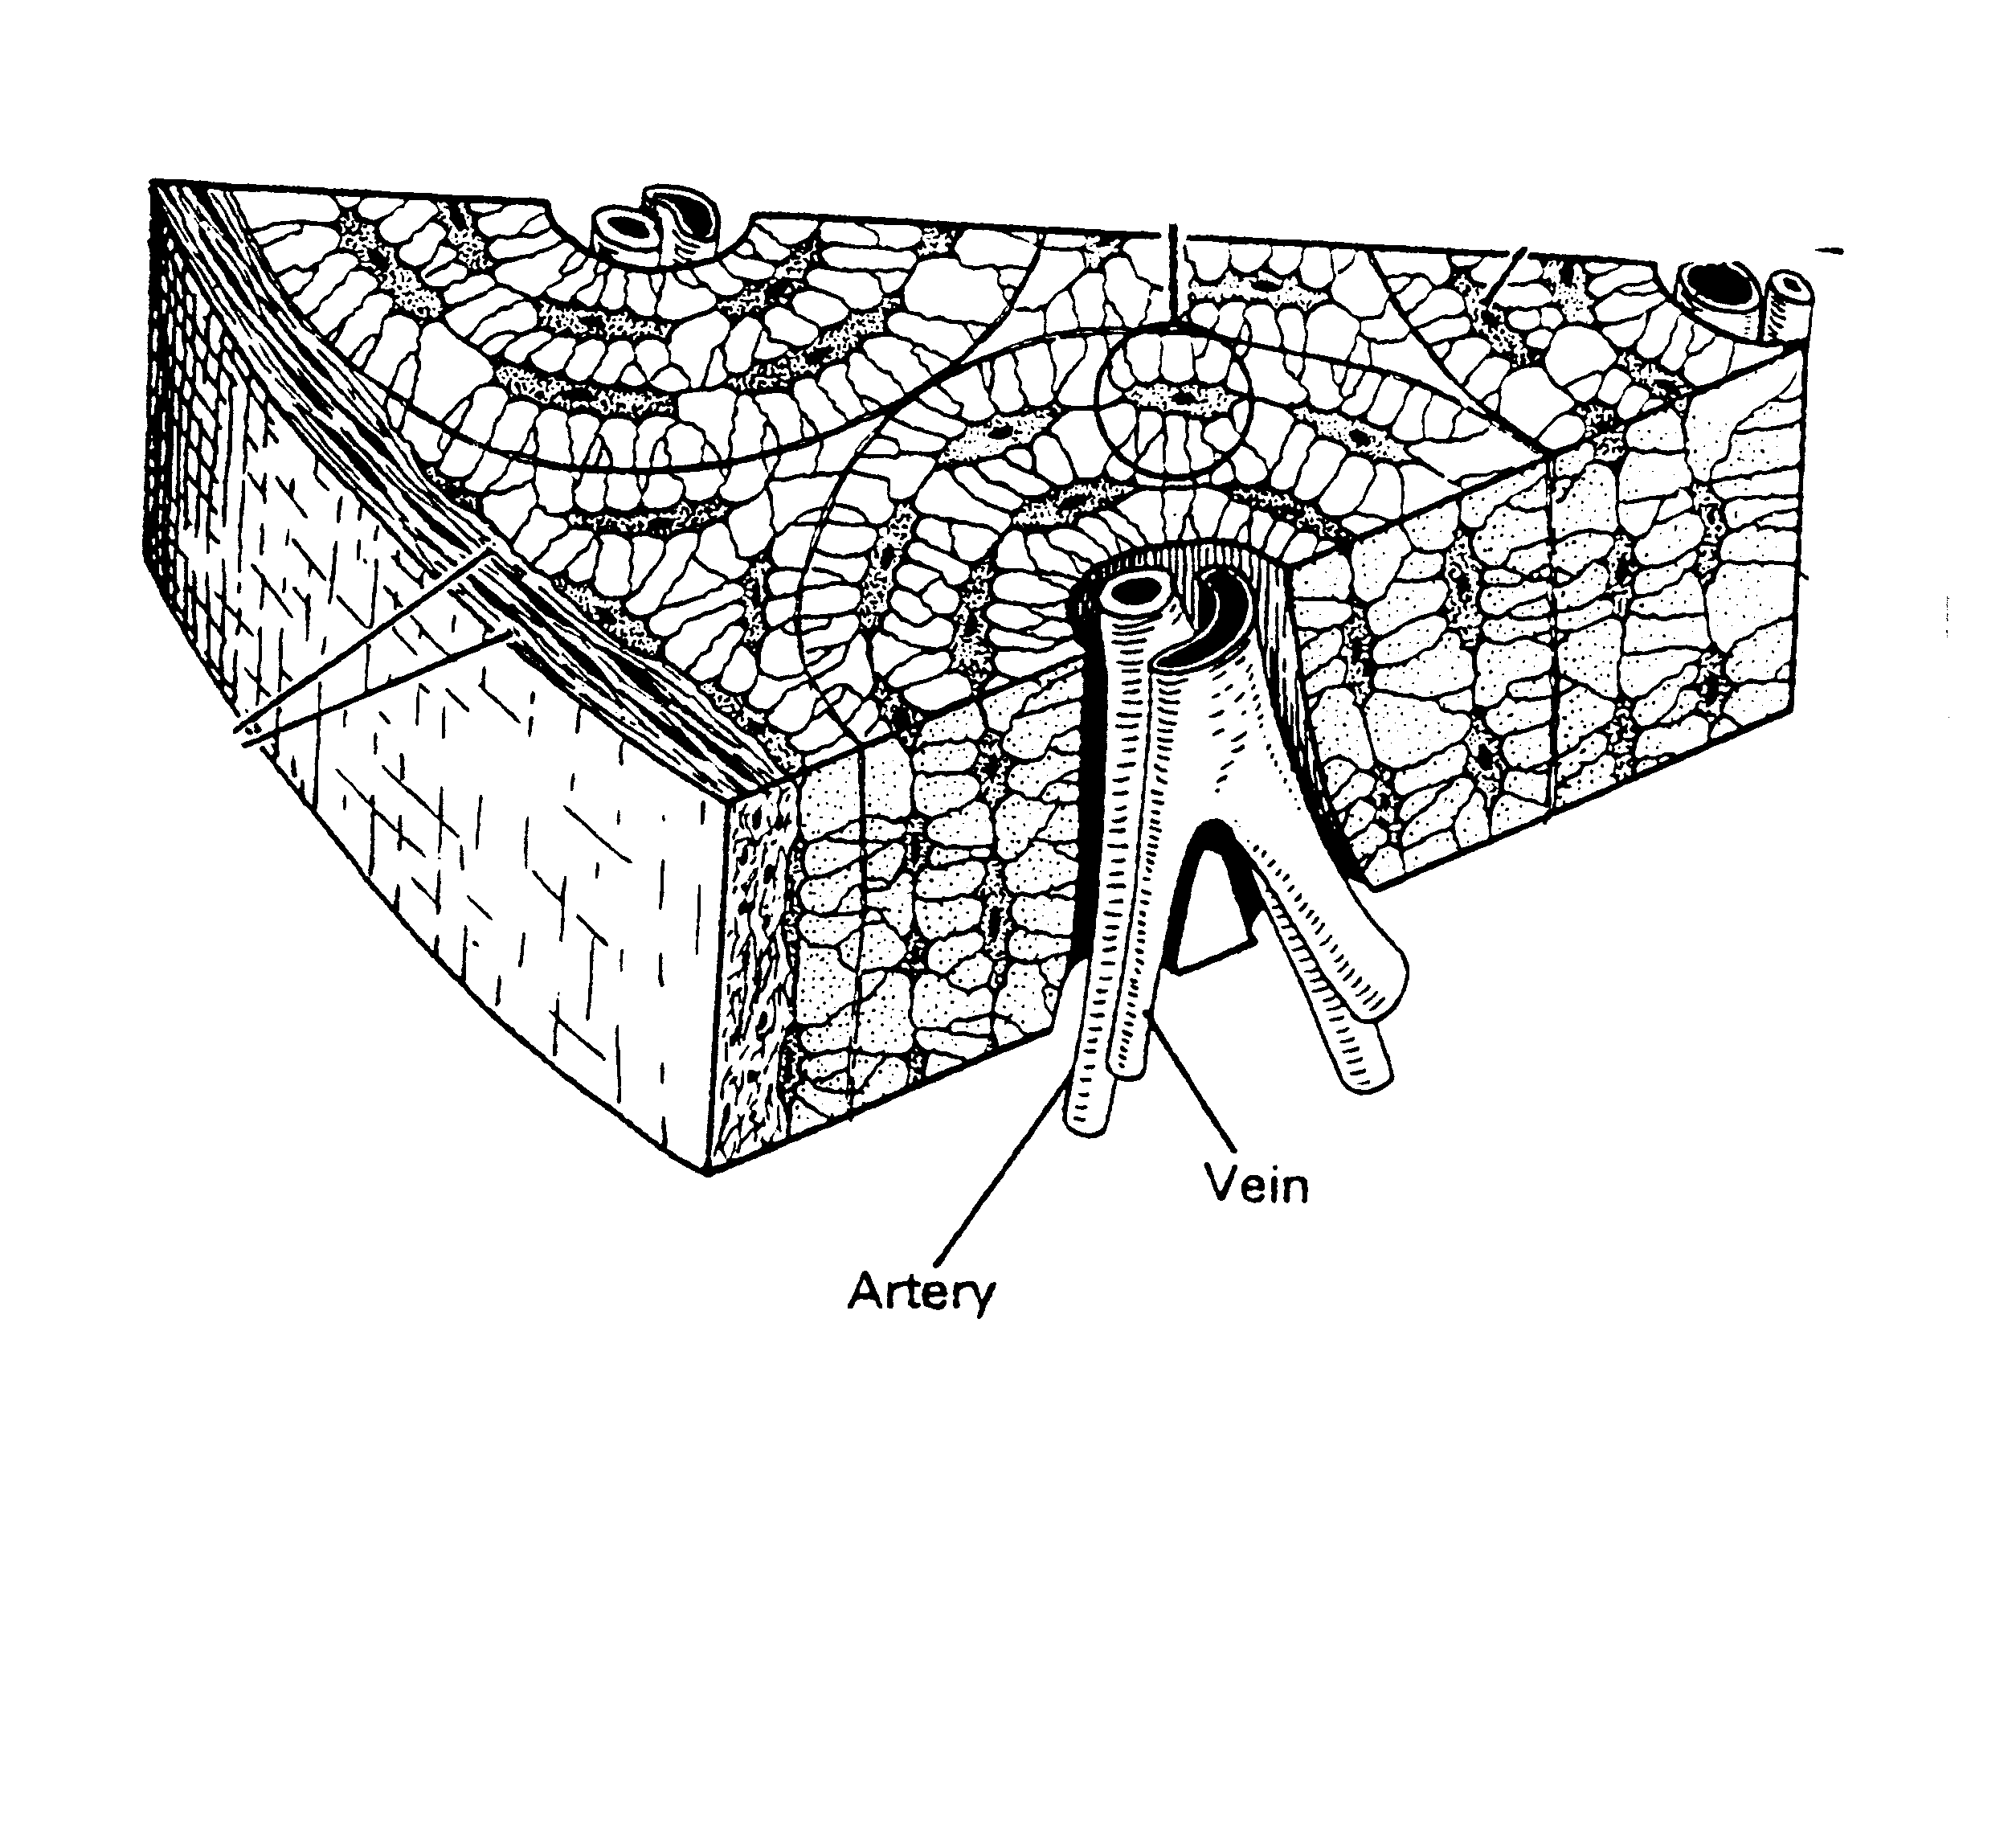

__________________________________________________________________

__________________________________________________________________

__________________________________________________________________

__________________________________________________________________

b
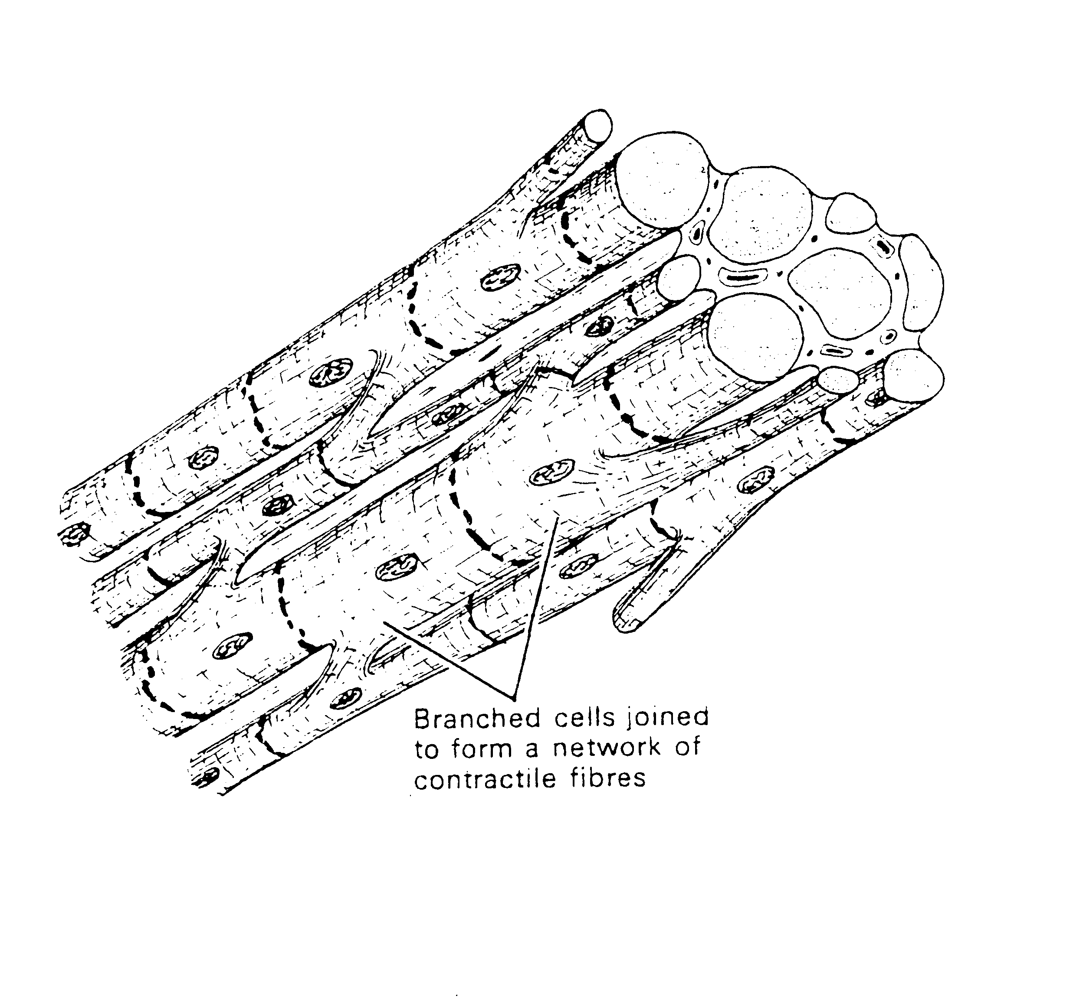
__________________________________________________________________

__________________________________________________________________

__________________________________________________________________

__________________________________________________________________

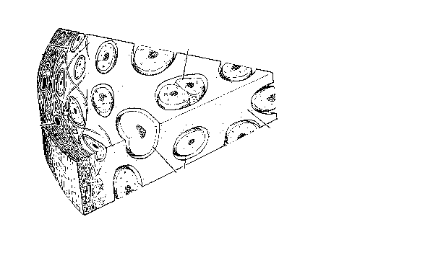

c.

__________________________________________________________________

__________________________________________________________________

__________________________________________________________________

__________________________________________________________________

(6 marks)

The following table displays how pH influences the activity of an enzyme.
pH | Enzyme Activity (international units)
1  2  3  4  5  6  7  8  9  10 | 8  10  15  28  35  77  90  110  76  24

- What is an enzyme and why are they essential for cell functioning?

__________________________________________________________________

__________________________________________________________________

__________________________________________________________________

___________________________________________________________
(2 marks)
v) From the table, what is the optimum pH for the enzyme being studied?
__________________________________________________________________
(1 mark)
vi) Consider the acidity of different parts of the digestive tract. From which part of the digestive tract would the enzyme being studied, originate? (Give reasons for your answers)
__________________________________________________________________

__________________________________________________________________

__________________________________________________________________

__________________________________________________________________
(2 marks)
vii) What other factors other than pH would influence the activity of an enzyme?

__________________________________________________________________
(1 mark)

- What is the name given to a substance on which an enzyme acts?

__________________________________________________________________
(1 mark)
ix) Name the cell organelle that manufactures enzymes.

__________________________________________________________________
(1 mark)

TOTAL /20

44
i) Associate the reproductive organs on the right with the correct description on the left.

________ 1.Tube for conducting sperm a. cervix.

________ 2. Receptacle for penis b. fallopian tube.

________ 3. Production of seminal secretions. c. Cowper’s gland.

________ 4. Conducts eggs. d. ovary.

________ 5. Holds baby in uterus e. prostate gland

________ 6. Produces sperm. f. testes.

________ 7. Prepares nutritive lining for embryo. g. urethra

h. uterus

g.vagina

j. vas deferens.

(7 marks)

Examine the following graph.
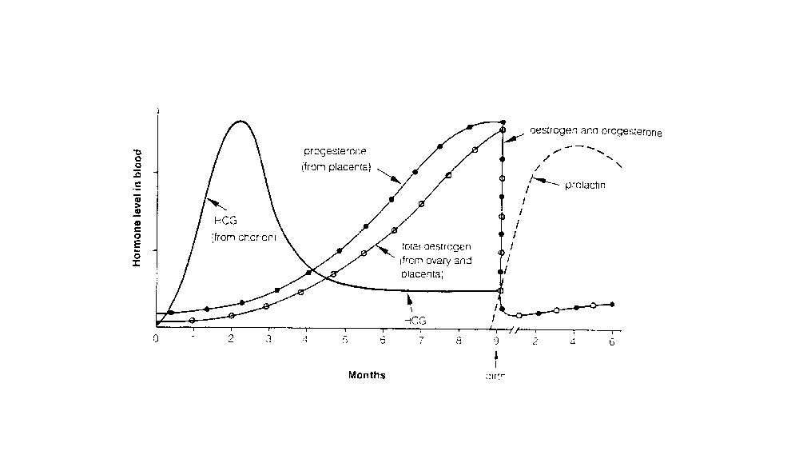ii) What happens to the levels of oestrogen and progesterone just prior to birth?

__________________________________________________________________
(1 mark)

iii) Explain what causes this change in hormonal levels?

__________________________________________________________________

__________________________________________________________________

__________________________________________________________________

__________________________________________________________________

__________________________________________________________________

(2 marks)

iv) Explain what happens to the level of prolactin immediately after birth and why this occurs?

__________________________________________________________________

__________________________________________________________________

__________________________________________________________________

__________________________________________________________________
(2 marks)

v) Oxytocin also plays an important role in lactation. Explain
.
__________________________________________________________________

__________________________________________________________________

__________________________________________________________________

__________________________________________________________________

__________________________________________________________________
(2 mark)

vii) List three benefits of breast-feeding.

1_______________________________________________________________

__________________________________________________________________

2_________________________________________________________________

__________________________________________________________________

3_________________________________________________________________

_________________________________________________________________
(3 marks)

- What structure produces the hormone responsible for male secondary sexual characteristics?

__________________________________________________________________

(1 mark)

- List two secondary male characteristics.

__________________________________________________________________

__________________________________________________________________
(1 marks)

TOTAL /20

45

Respiratory Gas | Approximate percentage of oxygen and carbon dioxide found during breathing
Respiratory Gas | Inhaled Air | Air in Lungs | Exhaled Air
Oxygen | 21% | 15% | 16%
Carbon Dioxide | 0.04% | 5.5% | 3.6%

The table above gives the approximate percentages of respiratory gases in inhaled and exhaled air, as well as in the lungs. Study the table and then answer the following questions.
- Compared to the air in the lungs, exhaled air has more oxygen and less carbon dioxide. Explain why this is the case?

__________________________________________________________________

__________________________________________________________________

__________________________________________________________________

__________________________________________________________________
(2 marks)

ii) Calculate the difference in CO₂ between inhaled and exhaled air and explain where this extra CO₂ comes from.

__________________________________________________________________

__________________________________________________________________
(2 mark)

iii) Calculate the difference in O₂ between inhaled and exhaled air.

__________________________________________________________________

__________________________________________________________________
(1 mark)

iv) Explain why it is not possible to kill yourself by holding your breath.

__________________________________________________________________

__________________________________________________________________

__________________________________________________________________

__________________________________________________________________
(2 marks)

v) Explain how the following is achieved in breathing.
a Inhalation (breathing in) ____________________________________________________________

____________________________________________________________

____________________________________________________________
b Exhalation (breathing out) ____________________________________________________________

____________________________________________________________

____________________________________________________________
(4 marks)

vi) The walls of the bronchioles have no supporting cartilage but a lot of smooth muscle. During an asthma attack, the muscle goes into spasm. Explain why this event closes the airways and makes breathing very difficult.

__________________________________________________________________

__________________________________________________________________

__________________________________________________________________

__________________________________________________________________

__________________________________________________________________
(2 marks)
vii) Explain the affect of aging on the following systems
- Respiratory

__________________________________________________________________

__________________________________________________________________

__________________________________________________________________

__________________________________________________________________
(2 marks)
b Nervous

__________________________________________________________________

__________________________________________________________________

__________________________________________________________________

__________________________________________________________________
(2 marks)

viii) Describe the three physiological stages of death by listing the characteristics of each stage.
a)
________________________________________________________________________

________________________________________________________________________

________________________________________________________________________
b)
________________________________________________________________________

________________________________________________________________________

_______________________________________________________________________
c)
________________________________________________________________________

________________________________________________________________________

________________________________________________________________________
(3 marks) TOTAL /20

Section C Extended Answer 20 Marks

Section C consists of two questions 46 and 47. You must answer one alternative from question 46 and one from 47. You must complete two questions. Marks may be deducted for answers, which are poorly presented or difficult to read. Use black or blue pen for written sections and pencil for diagrams. Answer must be written on the lined paper provided.

46
.a The importance of good nutrition begins at conception and continues throughout an individual life. Explain the adjustments that a pregnant woman needs to make to her diet and the pathway by which these nutrients are supplied from the mother to the developing unborn child.

(10 marks)

OR

b Compare the nutritional content of breast milk to cows milk and discuss the advantages and disadvantages of both methods of feeding a human infant.

(10 marks)

AND

47
a Cells require energy to carry out cellular functions. Explain the following.
- How cells utilise energy
- How and where is the energy produced
- The process by which energy is released within the cell
- The relationship of the ATP/ADP system and the importance of this relationship.
(10 marks)

OR

b Discuss the process of Meiosis by explaining
- The purpose
- Site
- Mechanism of this process
Include in your answer a discussion of gametogenesis in both males and females.
(10 marks)
NARROGIN SENIOR HIGH SCHOOL
YEAR 11HUMAN BIOLOGY EXAM – 2004 SEMESTER 2
MULTIPLE CHOICE ANSWER SHEET

NAME: ______________________________________
Instructions:
From the alternative given in the question, choose the answer, which is correct or best. Put a cross through the corresponding letter on the answer sheet below. If you make an error, circle your incorrect answer and mark the alternative you think is correct with a cross. Each question has only one correct answer.

1. | A | B | C | D | E |  | 21. | A | B | C | D | E
2. | A | B | C | D | E |  | 22. | A | B | C | D | E
3. | A | B | C | D | E |  | 23. | A | B | C | D | E
4. | A | B | C | D | E |  | 24. | A | B | C | D | E
5 | A | B | C | D | E |  | 25. | A | B | C | D | E
6. | A | B | C | D | E |  | 26. | A | B | C | D | E
7. | A | B | C | D | E |  | 27. | A | B | C | D | E
8. | A | B | C | D | E |  | 28. | A | B | C | D | E
9. | A | B | C | D | E |  | 29. | A | B | C | D | E
10 | A | B | C | D | E |  | 30. | A | B | C | D | E
11 | A | B | C | D | E |  | 31. | A | B | C | D | E
12 | A | B | C | D | E |  | 32. | A | B | C | D | E
13 | A | B | C | D | E |  | 33. | A | B | C | D | E
14 | A | B | C | D | E |  | 34. | A | B | C | D | E
15 | A | B | C | D | E |  | 35. | A | B | C | D | E

16 | A | B | C | D | E |  | 36 | A | B | C | D | E
17 | A | B | C | D | E |  | 37 | A | B | C | D | E
18 | A | B | C | D | E |  | 38. | A | B | C | D | E
19 | A | B | C | D | E |  | 39. | A | B | C | D | E
20 | A | B | C | D | E |  | 40. | A | B | C | D | E

